MADAM BOUTIQUE

|  |  |  |
| --- | --- | --- |
| **Supervisor:** | Sir.Ubaidullah | |
| **Batch:** | 2410c. | |
| **Group:** | MADAMBOUTIQUE | |
| **Serial No.** | **Enrollment No.** | **Student Name.** |
| 1. | 1616223 | Dakesh. |
| 2. | 1613863 | Abdul Ahad. |
| 3. | 1616485 | Azam. |
| 4. | 1616432 | Sadia. |

***Acknowledgement***

I would like to express my heartfelt gratitude to my mentors, **Sir Usman, Sir Ubaidullah,** for their invaluable guidance, encouragement, and continuous support throughout the development of **MadamBoutique**. Their expertise and insightful advice played a crucial role in successfully completing this project within the given timeframe.

Additionally, I extend my sincere appreciation to the **e-Project team at Aptech Head Office** for providing us with this incredible opportunity to work on such an engaging and meaningful project. Their assistance and resources significantly contributed to our learning experience.

This project has provided us with numerous benefits, including:

* Enhancing our skills through practical, hands-on experience.
* Receiving constant guidance from mentors to stay focused and achieve our objectives.
* Gaining confidence in our abilities, which will be invaluable in future professional endeavors and interviews.

I am truly grateful to everyone who played a role in the successful completion of **MadamBoutique**.

***Synopsis***

**"MadamBoutique"** is an innovative and stylish online platform that redefines fashion by offering a curated collection of elegant and trendy clothing for both men and women. With a commitment to quality, sophistication, and modern aesthetics, MadamBoutique stands as a one-stop destination for fashion enthusiasts who seek both timeless classics and contemporary designs.

At the heart of **MadamBoutique** is a passion for fashion that blends creativity with craftsmanship. Each piece is carefully selected to cater to diverse styles, ensuring that every customer finds something that resonates with their personality. Whether it's chic formal wear, trendy casual outfits, or statement pieces for special occasions, MadamBoutique delivers fashion that speaks volumes.

Beyond just clothing, **MadamBoutique** is an experience—where innovation meets elegance. With user-friendly navigation, seamless shopping features, and a responsive design, the website provides a hassle-free shopping journey. The inclusion of a dynamic search bar, captivating carousel sliders, and an engaging "New Arrivals" section with smooth horizontal sliding ensures that customers stay updated with the latest trends effortlessly.

As **MadamBoutique** continues to grow, it remains dedicated to offering quality, affordability, and an unmatched shopping experience. Whether you're looking to revamp your wardrobe or find the perfect outfit, MadamBoutique is here to inspire and elevate your style.

***Problems Definition***

Running an online fashion store like **MadamBoutique** comes with various challenges, the most significant being **inventory management and website performance**. Keeping track of stock levels, updating product availability, and preventing overselling or shortages is crucial to ensuring a smooth shopping experience. Additionally, a fast and user-friendly website is essential, as slow loading times, navigation issues, or technical glitches can frustrate customers and negatively impact sales.

Another major challenge is **customer engagement and order fulfillment**. In a competitive market, attracting and retaining customers requires seamless browsing, personalized recommendations, and responsive support. Delays in order processing, shipping, or tracking can lead to dissatisfaction and loss of trust. Ensuring a secure payment system and smooth checkout process is also essential to building customer confidence and long-term loyalty. Addressing these challenges will help **MadamBoutique** provide a superior shopping experience and drive business growth.

***Customer Requirement Specification (CRS)***

The **MadamBoutique** website is a single-page, front-end fashion platform designed for a seamless and visually appealing user experience.

### ****Features:****

* **Smooth Navigation Bar:** Includes **Home, About, Contact, and Gallery** sections along with a brand logo for easy navigation.
* **Slider Section:** A dynamic image slider placed below the navbar to showcase promotions or featured collections.
* **Women Outfit Section:** Displays a curated selection of women's fashion items.
* **Men Outfit Section:** Features stylish clothing options for men.
* **Gallery Section:** Categorized into **All, Men, Women, and Hit Collection**, allowing users to explore different fashion trends.
* **About Us Section:** Showcases team members with their pictures and names, offering insight into the brand's identity.
* **Contact Us Section:**
  + **Left Side:** Contains a short paragraph, contact details (phone, Gmail, and location).
  + **Right Side:** Includes a user-friendly inquiry form and an embedded Google Map showing the store location.
* **Footer:** Positioned at the bottom of the page for additional information or quick links.

### ****User Interaction:****

* Users can **navigate smoothly** between sections using the navbar.
* The **Gallery Section** allows users to filter and view fashion collections based on categories.
* The **Contact Section** provides easy access to store details and customer inquiries.

This **front-end design** ensures an intuitive and engaging shopping experience, setting a strong foundation for future enhancements.

***Wireframes***

***Home page***

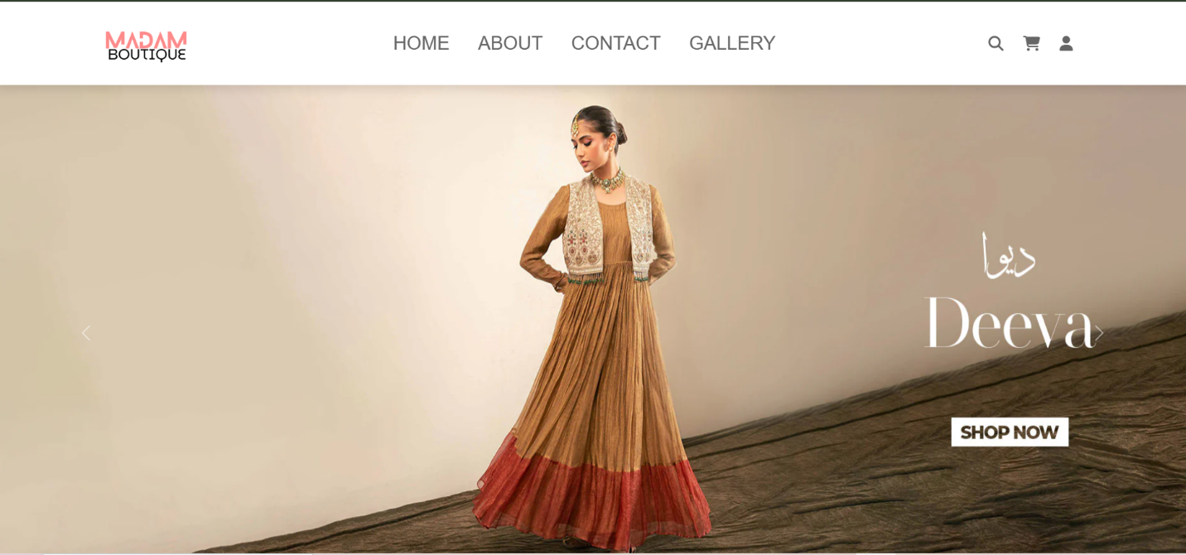

***Contact Us***

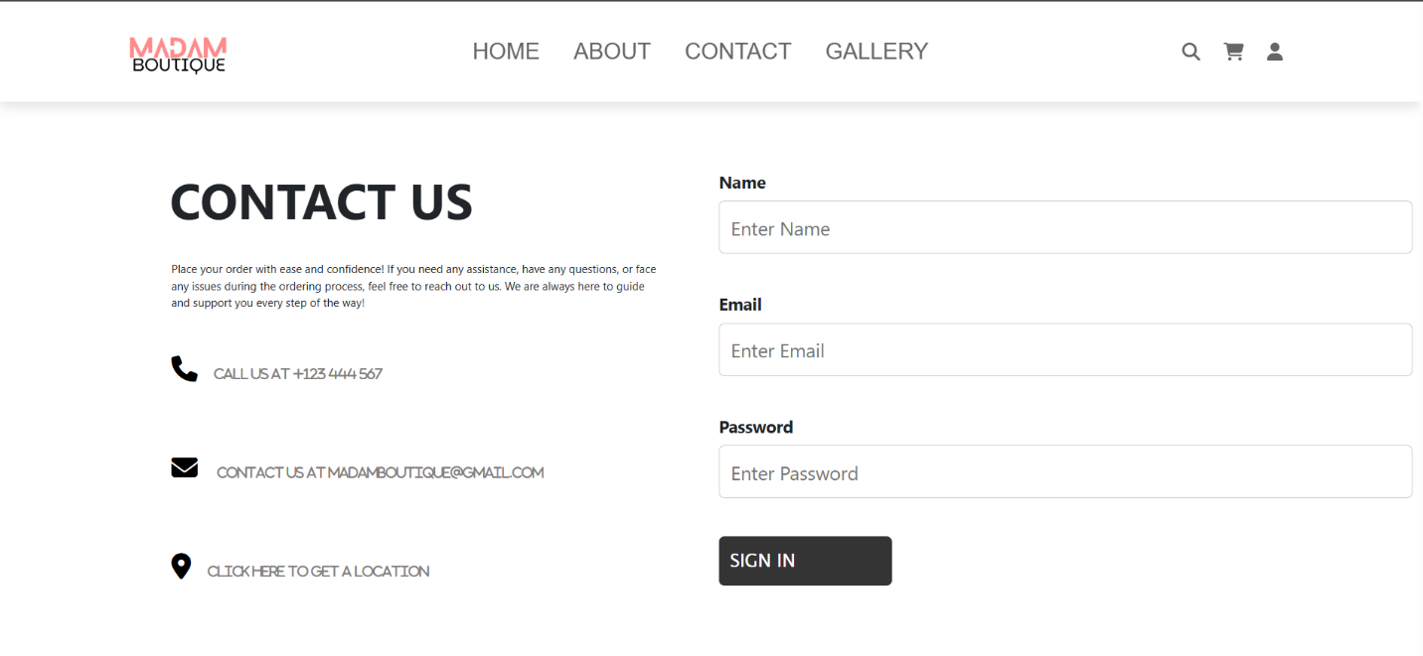

**About Us**

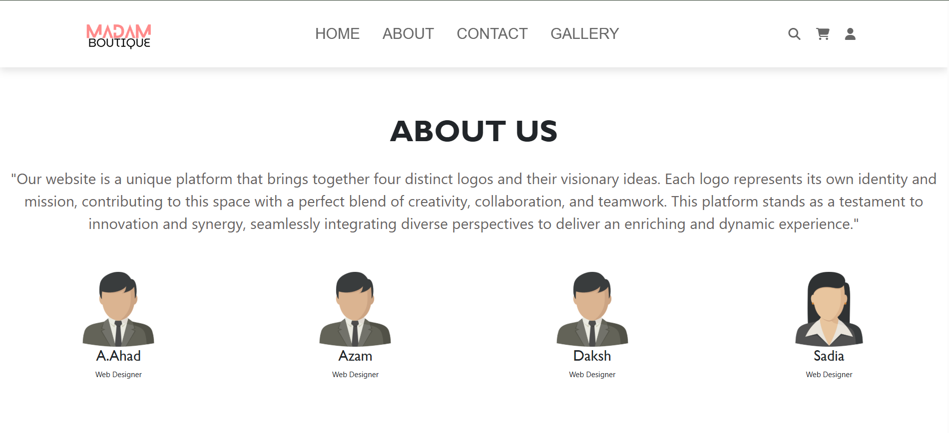

**Gallery Section**

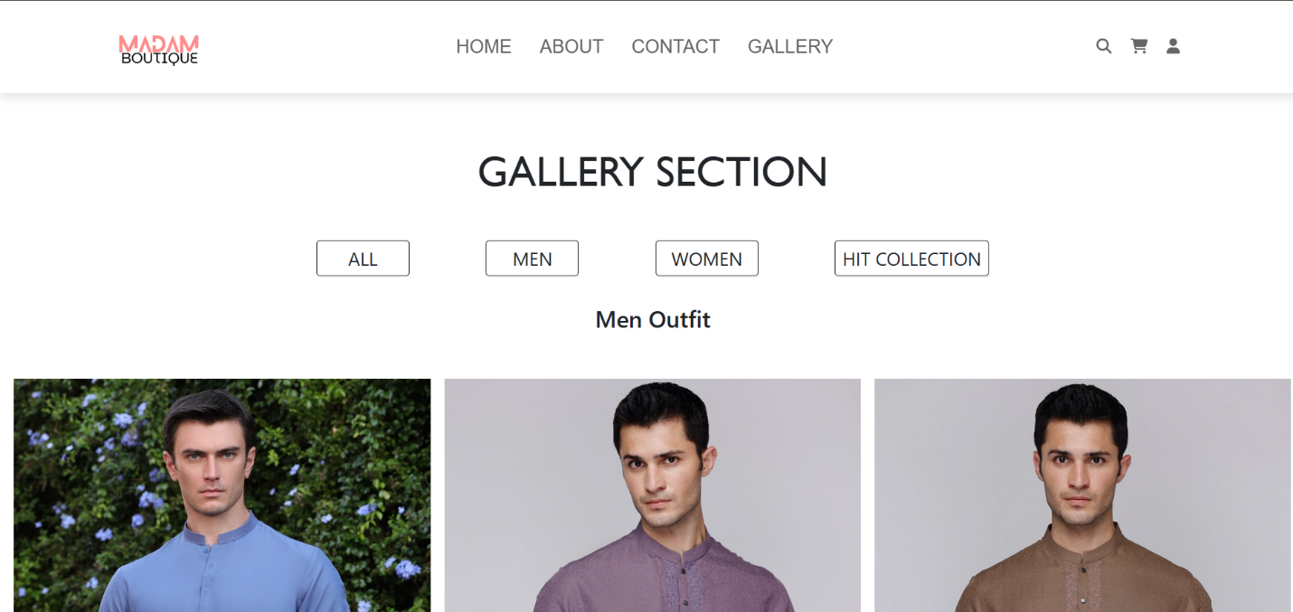

**Our Team**

*"Dakesh" , "Abdul Ahad","Azam","Sadia"*

***Task Sheet***

|  |  |  |  |  |  |  |
| --- | --- | --- | --- | --- | --- | --- |
| **Website Pages** | | **ProjectTitle** | **Date Of preparation Of Activity Plan** | | | |
| No. | ***Task*** | **M**  **A**  **D**  **A**  **M**  **B**  **O**  **U**  **T**  **I**  **Q**  **U**  **E** | ***Actual***  ***Start Date*** | ***Actual Days*** | ***Team-Mate***  ***Name*** | ***Status*** |
| 01. | ***Home page*** | 10  -  F  e  b  r  u  a  r  y  -  2  0  2  5 | 3  0  -  D  A  Y  S  - | DAKESH |  |
| 02. | ***Men/Women Outfit*** | Abdul Ahad |  |
| 03. | ***Gallery page*** | Dakesh |  |
| 04. | ***About page*** | Abdul Ahad |  |
| 05. | ***Contact us page*** | Dakesh |  |
| 06. | ***Documentation /*** | Dakesh |  |
| 07. | ***Footer*** |  |  |  | Azam/Sadia |  |